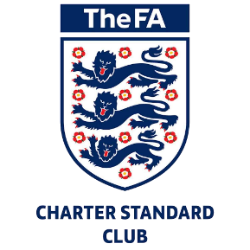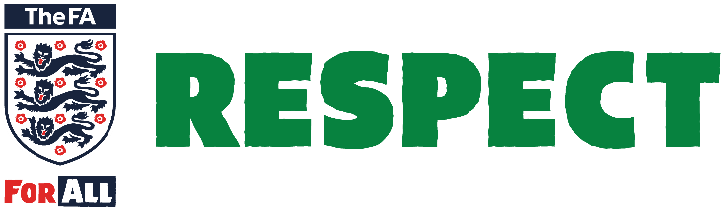

Complaints Policy

In the event that any member feels that they haves suffered discrimination in anyway or that the Club Policies, Rules or Code of Conduct, has been broken they should follow the procedures below.

Please note that issues involving concerns around child welfare or abuse, where a more confidential approach is required, can be reported confidentially to the Club’s Child Welfare Officer in accordance with the Safeguarding Children Policy

**Informal Complaint (Stage 1)**

The vast majority of issues can be dealt with informally, and within the age group. A member may wish to raise a verbal complaint with the manager / coach involved and the matter is resolved quickly. Alternatively a manager may speak to a parent to resolve some issue of touchline behaviour. An exchange of e‐mails, and/or telephone calls would also be considered an example of an informal complaint.

**Formal Complaint (Stage 2)**

If either party feels that the issue cannot be dealt with informally, or that the response to Stage 1 was not satisfactory, then they should report the matter to the Club Secretary.

The report should include:

* Details of what, when, and where the occurrence took place
* Any witness statement and names
* Names of any others who have been treated in a similar way (if appropriate)
* Details of any former complaints made about the incident, date, when and to whom made (if known).
* A preference for a solution to the incident.

This formal complaint will be considered by the Management Committee. They will usually arrange to gather facts from both parties and attempt to mediate between the parties and achieve reconciliation.

The Club’s Management Committee will aim to respond to your complaint within 10 days. If the complaint is complex or needs investigation you can expect a holding letter within 10 days and a detailed response within 30 days.

The Club’s Management Committee will have the power to:

* Warn as to future conduct
* Suspend from membership
* Remove from membership any person found to have broken the Club’s Policies or Codes of Conduct.

If the complaint is with regard to the Club’s Management Committee the member has the right to report the matter direct to the County Football Association.

Notes of all meetings will be kept, and a letter will be written to the parties involved by Management Committee (usually within one month).

Contact details for the key Officers referred to above are available via the Club’s website www.malpasfc.co.uk

As the governing body of the game, The FA is responsible for setting standards and values to apply throughout the game at every level. Football belongs to, and should be enjoyed by everyone equally.

Our commitment is to promoting equality of access and opportunity by recognising that inequalities exist and taking practical steps to address them. The FA is /are committed to eliminating discrimination and harassment. This includes whether by reason of gender, sexual orientation, race, nationality, ethnic origin, colour, religion or ability.